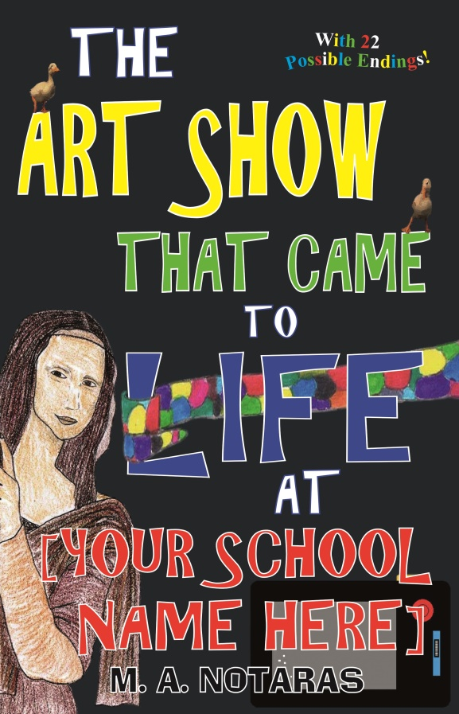
Can you imagine what could happen if [Your School Name Here]’s art show suddenly came to life?
Can you outwit a crazy Mona Lisa? Stop an evil Sculptor from turning you into a Lego statue? Save your school from a smashing, crashing, teacher-swallowing Glob Man – on the back of a gigantic cat? Monsters, magic, chases, escapes – it’s no ordinary art show at [Your School Name Here], where only the brave at ‘art survive, and what happens next is up to YOU!
[Your School Name Here] P&C/P&F/PTO is excited to announce their latest fundraiser that’s both fun and educational - and is a great way to encourage your kids to read! It’s The Art Show That Came To Life At [Your school name here], an adventure story customised for OUR SCHOOL that gets kids excited about reading because it stars FOUR of OUR very own [Your School Name Here] TEACHERS in a funny, wacky, adventure tale set right here at [Your School Name Here]! Featuring lots of school and local details so your child feels like they’re right in the middle of the story – and with 22 possible endings, they decide what happens next (like a ‘Choose Your Own Adventure’ novel)! Read by yourself, or together with parents. It’s fun to read again and again – with a different ending every time! 124 pages, 40 black &white illustrations.
We have four daring teachers ready to star in the book! Who are they? Find out in the story!
Please return your payment by [date]. Note this fundraiser requires a minimum order of 50 books; in the event that we don’t reach that number your payment will be returned.
----------------------------------------------------------------------------------------------------------------------------
THE ART SHOW THAT CAME TO LIFE AT [YOUR SCHOOL NAME HERE]
Student Name:…………………………………………………………………. Class: …………………..
Yes! I would like to order …………….….. books at $20 each, enclosing a total payment of $.......................................

